Generate AI:

--------------------

Use Case and Architecture:

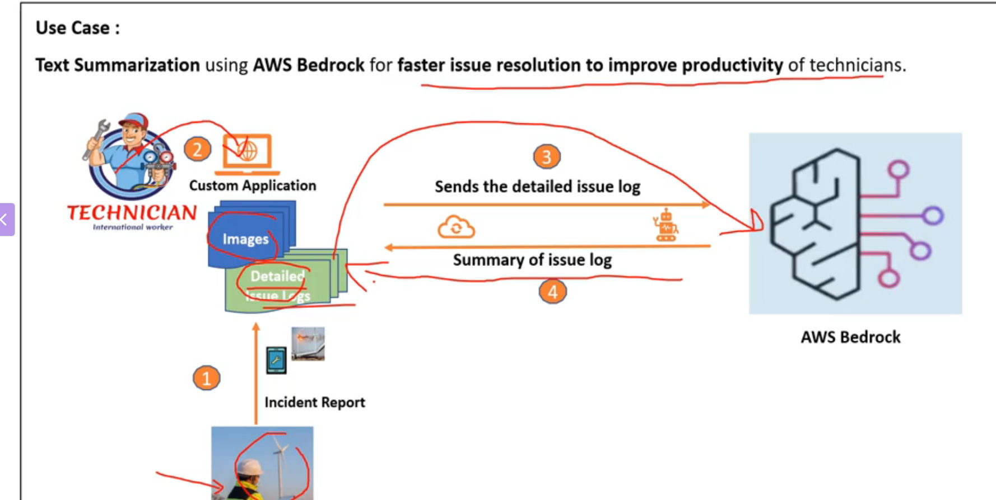

* So if you look at any large equipment manufacturer, such as manufacturers for turbines or windmills

you will see that these windmills will be deployed in remote locations.

* And if there is ever a failure, then you will have a technician who will be at this remote site, will

take some pictures and create a detailed issue log.

* Then these images of the breakdown and the detailed issue log would be accessed by a technician sitting

at a remote office through maybe a custom application that's been built.

-🡪 Now, the challenge is that once this technician looks at these images and detailed issue logs, sometimes

a detailed issue log can be too detailed and time consuming for this technician to look through.

So now the question is how can generative AI help here?

* One possibility to improve the productivity of technician is to send these detailed issue logs to bedrock.

And bedrock invokes one of the foundation models and then summarizes the key issue log and sends it

back to the technician.

Then the technician can look at this summary of issue log rather than the entire detailed issue log

to help make decisions faster.

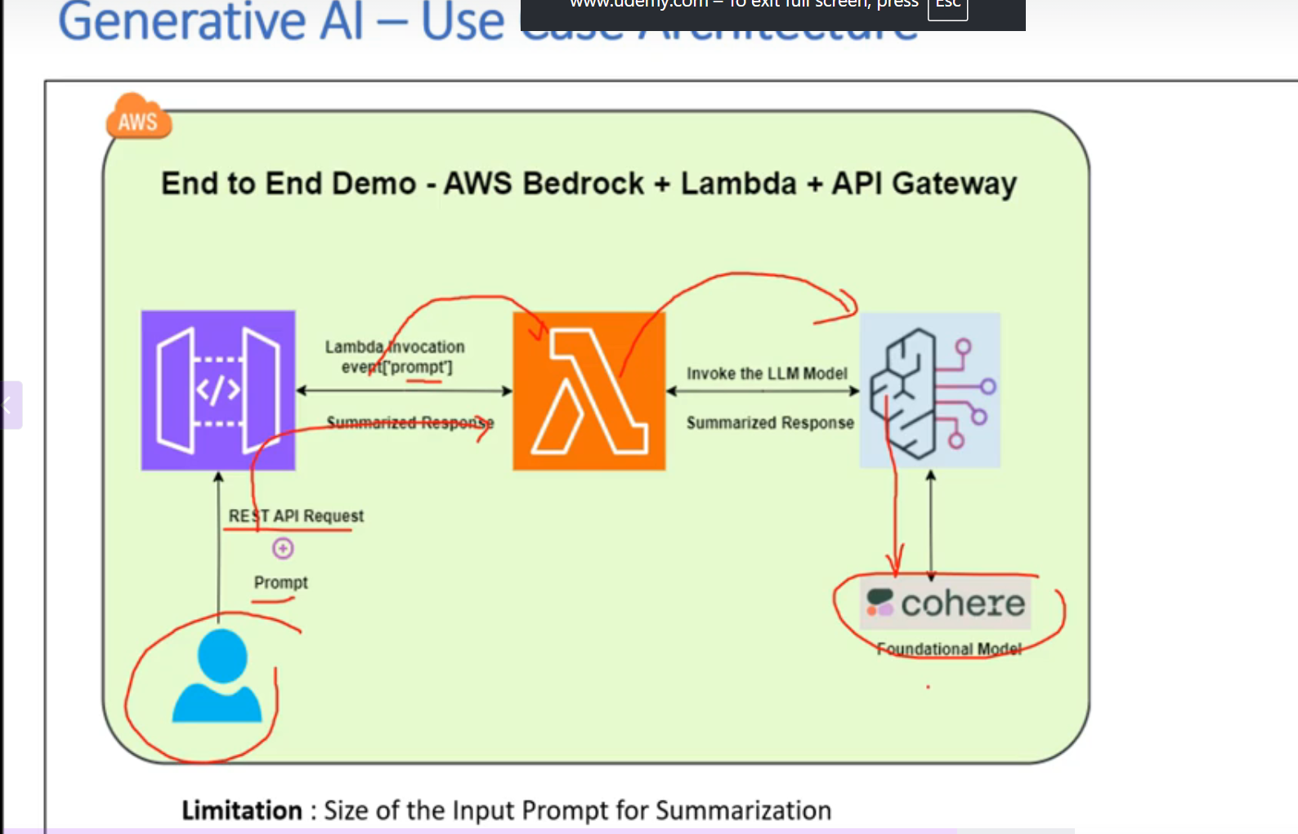

Now let's take a look at the architecture that we're going to build as part of this use case.

* So here we have the user which is a technician in our case sitting in some remote office.
* So we'll invoke a Rest API and then send a prompt along with this API request. And this prompt in our case will be a detailed issue log.

So once this Rest API has been invoked it is going to trigger a lambda function.

* And then this prompt is going to be passed as an event to AWS Lambda function.

And then this Lambda function is going to invoke the bedrock API and query a foundation model that we

have selected.

* So in our case for this use case I have selected the Career Foundation model which will be using for

text summarization.

* Now how we can select the right foundation model will depend on a lot of parameters such as modality.

Whether it's for image generation or for text or summarization.

The cost of the foundation model. COHERE foundation model

There are multiple factors.

Maybe I'll create a separate video to describe what are the factors that you take into account for selecting

the right foundation model.

* Now there is a little bit of a limitation to this architecture in terms of size of the input prompt

that you can use for summarization.

* So you can have the prompt only up to certain characters. The reason being that the prompt is too long.

Then we have to introduce another element called as aslauche.

But for now we are just going to stick with this architecture and we're going to provide a relatively

short prompt. And when I say prompt, it means the user input.

Generate AI: -🡪 Bedrock Overview

--------------------------------------------------

Amazon Bedrock:

* **Bedrock configurations**
* [Model access](https://905418111046-p2xmdjap.us-east-1.console.aws.amazon.com/bedrock/home?region=us-east-1#modelaccess)

Bedrock models

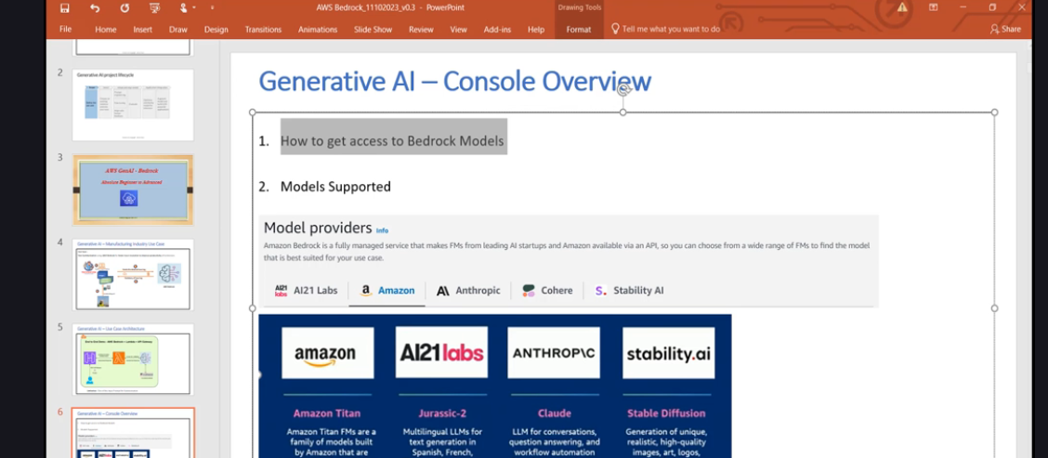

Model access

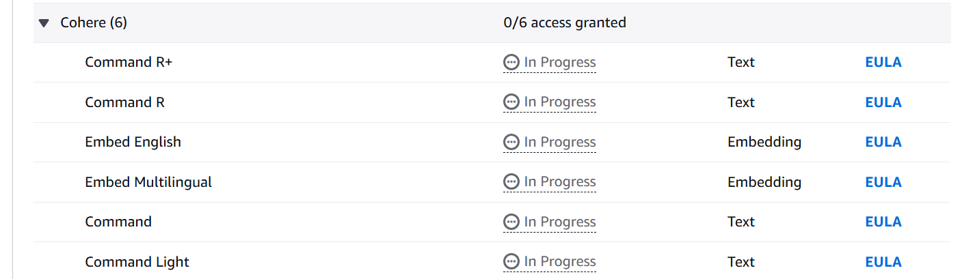

3rd Class:

------------------

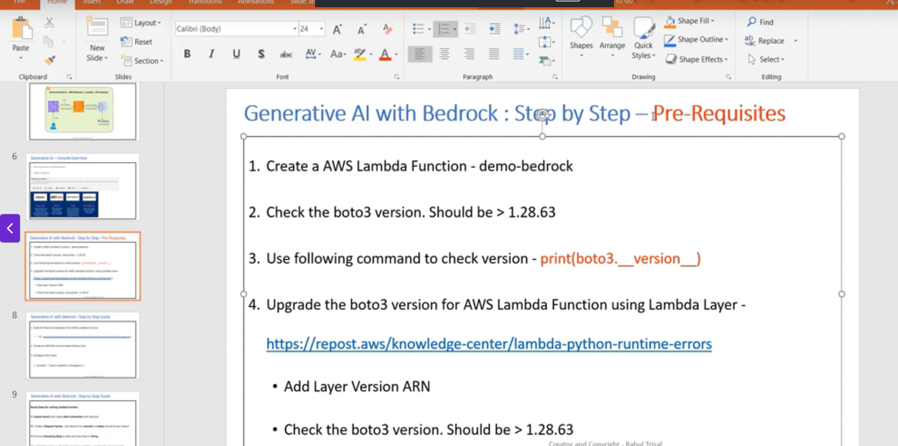

<https://repost.aws/knowledge-center/lambda-python-runtime-errors>

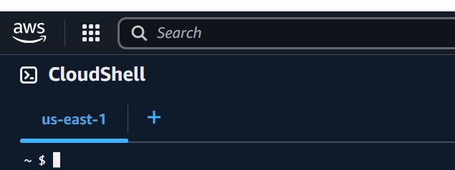

Step 1:

import json

#1 Import boto3 and create client connection with bedrock

import boto3

client = boto3.client('bedrock-runtime')

#print(boto3.__version__)

Function Logs:

1.35.92 (min required 1.28.63)

If not upgrade to 1.28.63 atleast

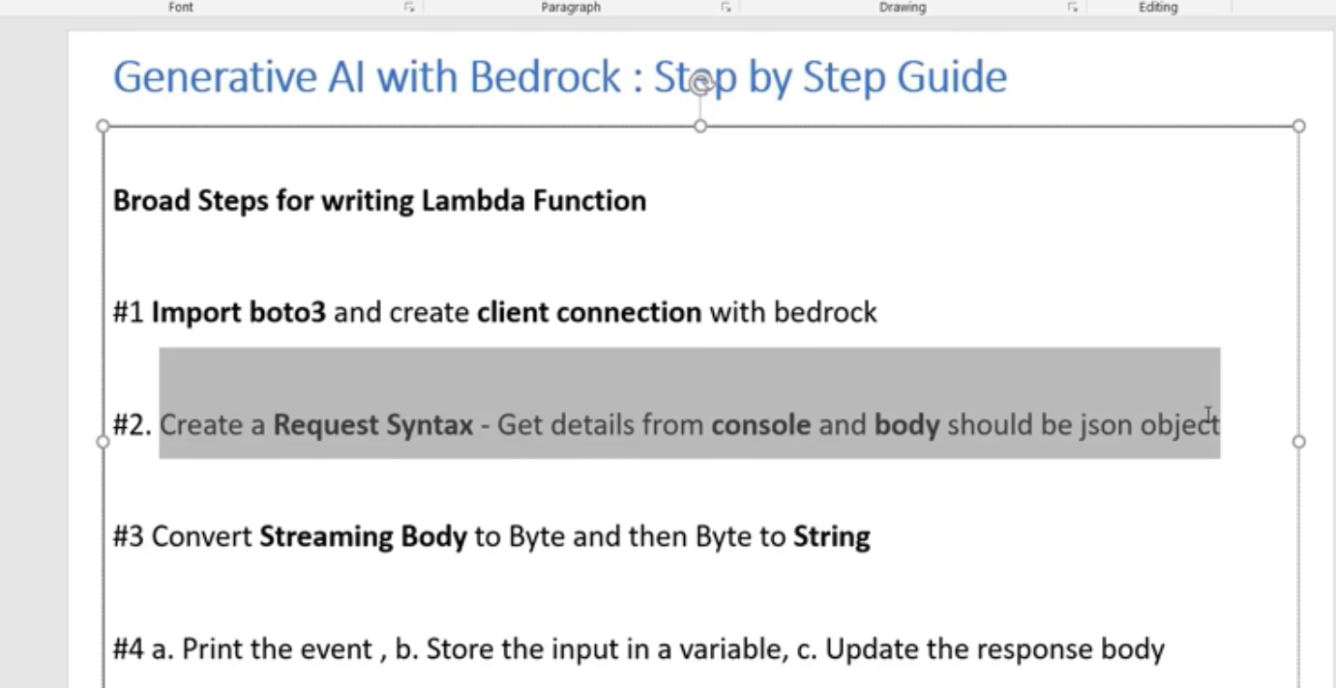

client = boto3.client('bedrock-runtime')

2.

<https://boto3.amazonaws.com/v1/documentation/api/1.28.63/reference/services/bedrock-runtime.html>

<https://boto3.amazonaws.com/v1/documentation/api/1.28.63/reference/services/bedrock-runtime/client/invoke_model.html>

Model ID

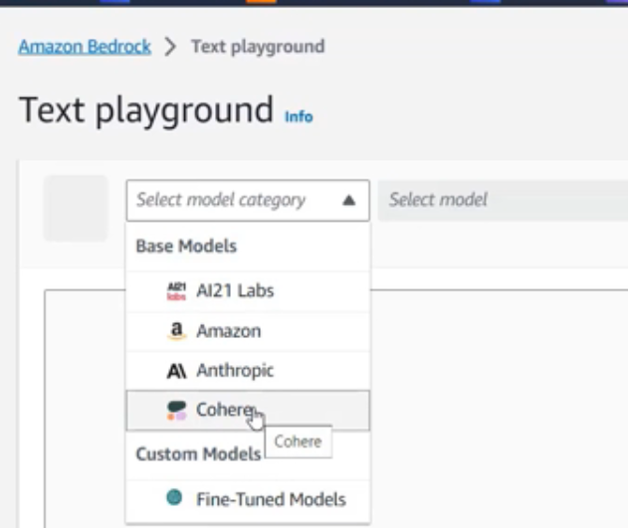

1.46

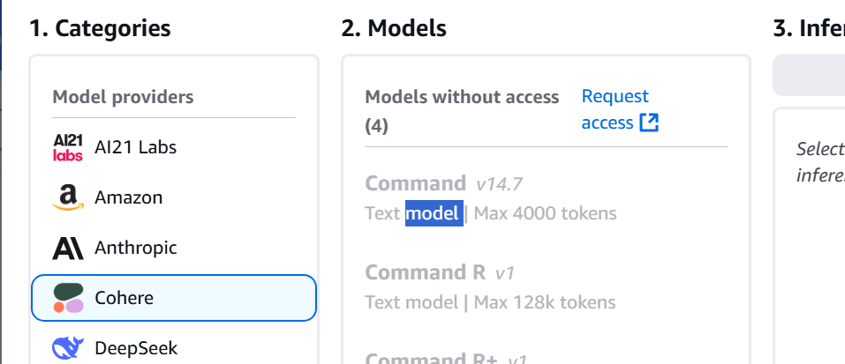

Hello

View API request:

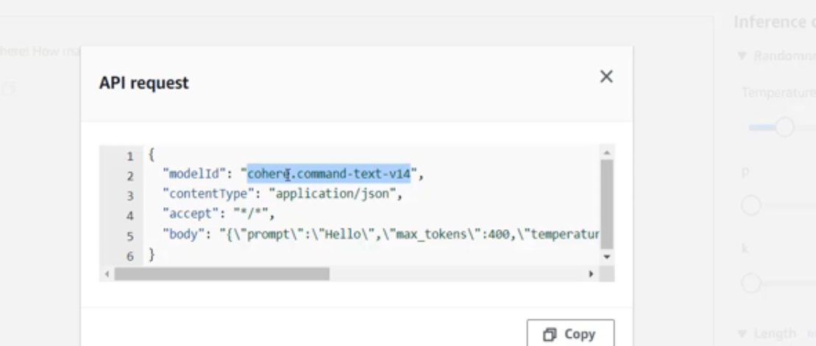

modelId='cohere.command-text-v14')

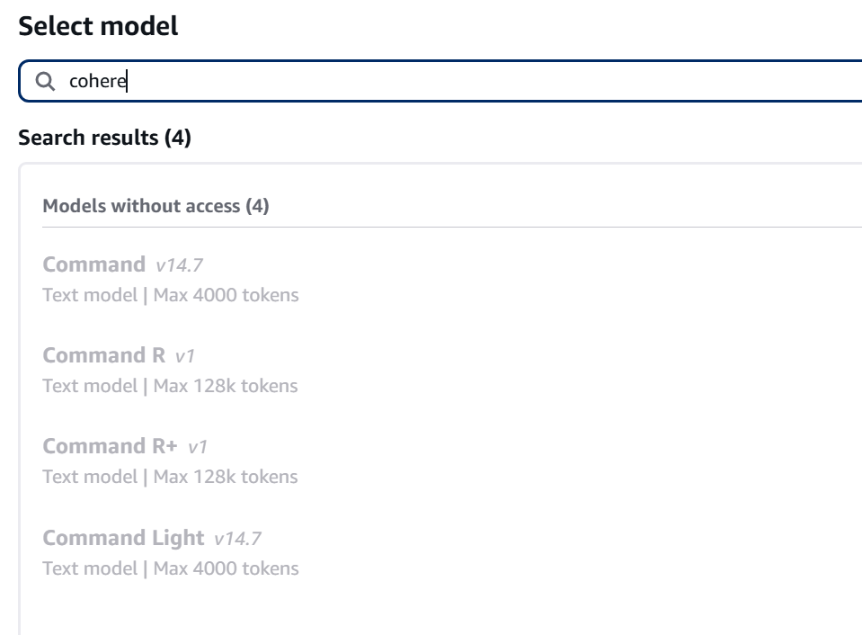

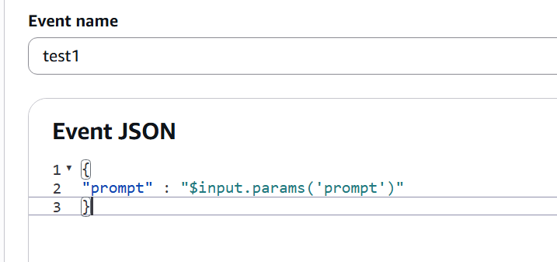

IAM

[AmazonBedrockFullAccess](https://905418111046-p2xmdjap.us-east-1.console.aws.amazon.com/iam/home#/policies/details/arn%3Aaws%3Aiam%3A%3Aaws%3Apolicy%2FAmazonBedrockFullAccess)

modelId='cohere.command-text-v14')

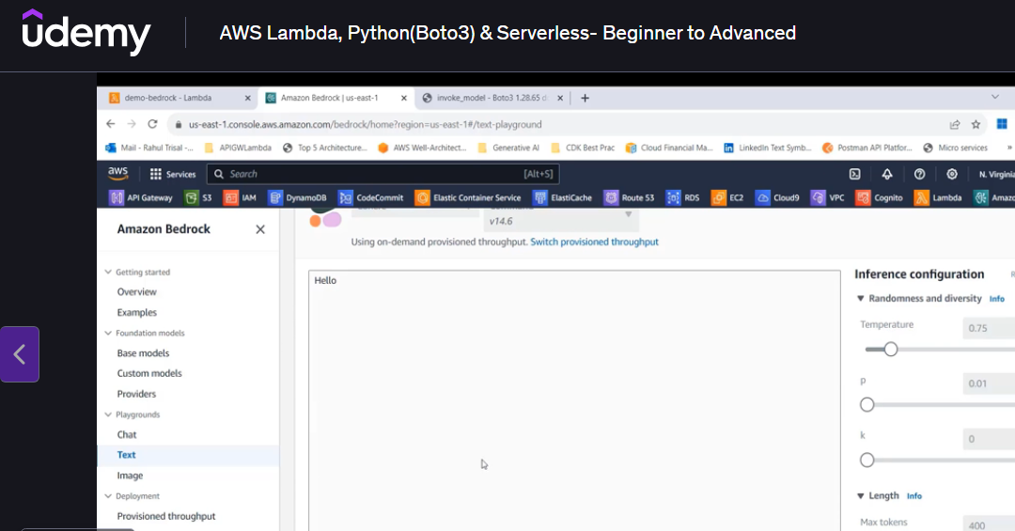

Test

* Interference parameters

body=json.dumps({"prompt": user_prompt,"temperature": 0.9,"max_tokens": 100})

1.

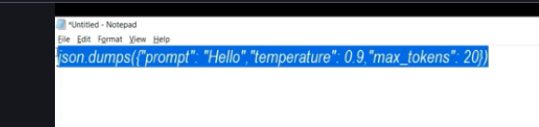

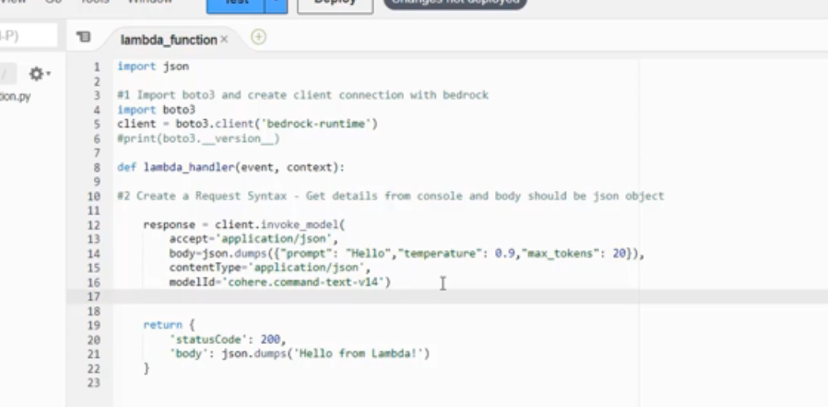

If any ACCESS denied error

[AmazonBedrockFullAccess](https://905418111046-p2xmdjap.us-east-1.console.aws.amazon.com/iam/home?#/policies/details/arn%3Aaws%3Aiam%3A%3Aaws%3Apolicy%2FAmazonBedrockFullAccess)

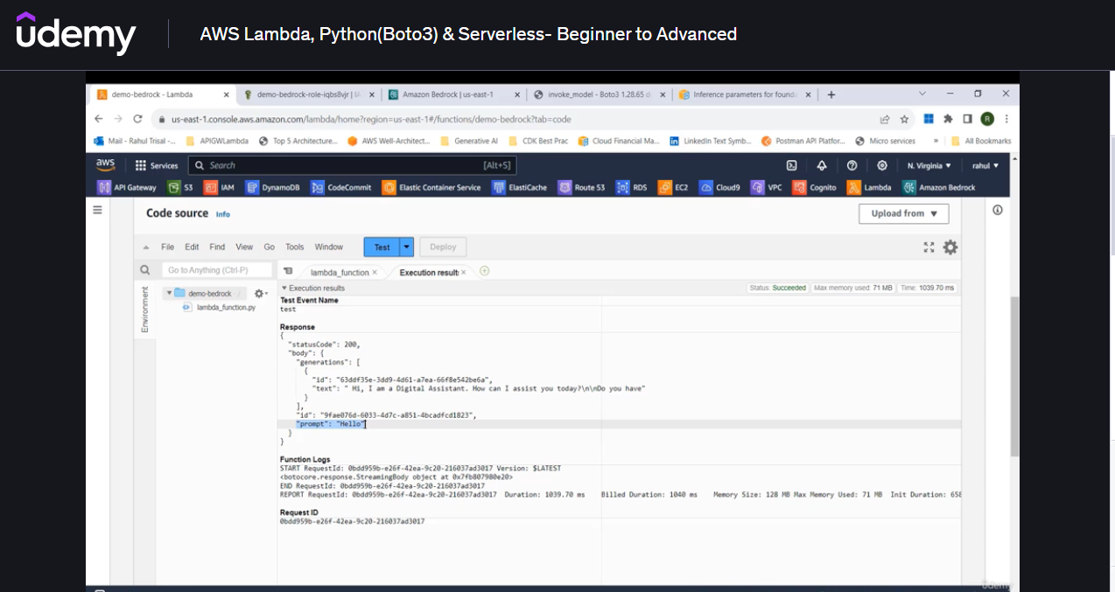

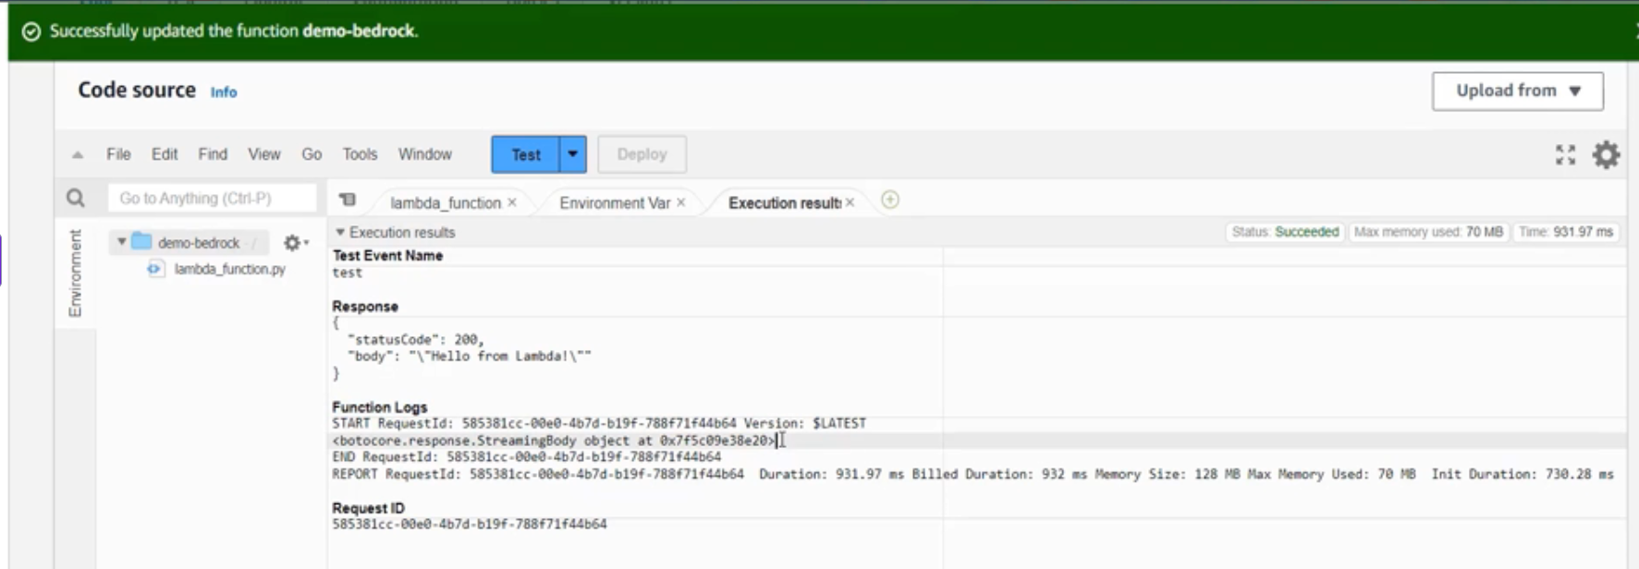

STEP 2:

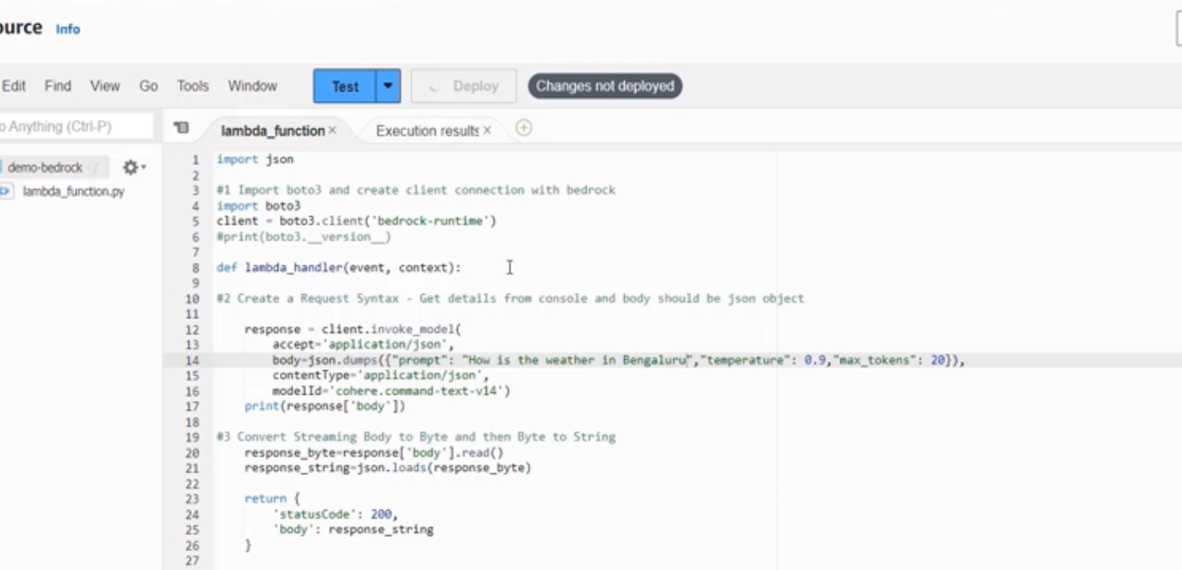

Output:

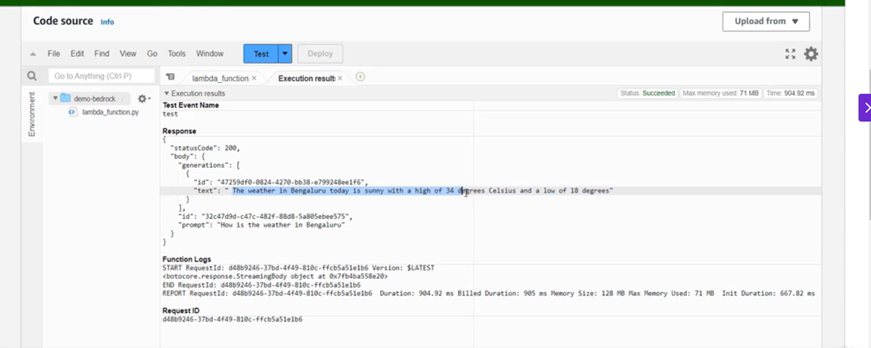

Step 3:

Test Event

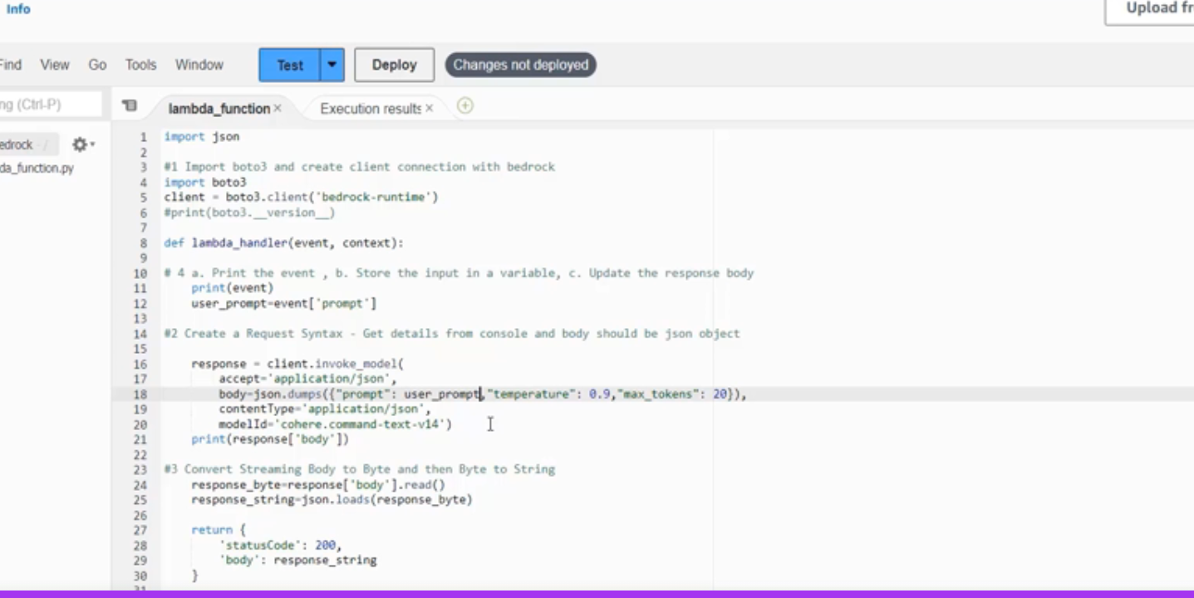

Test EVENT:

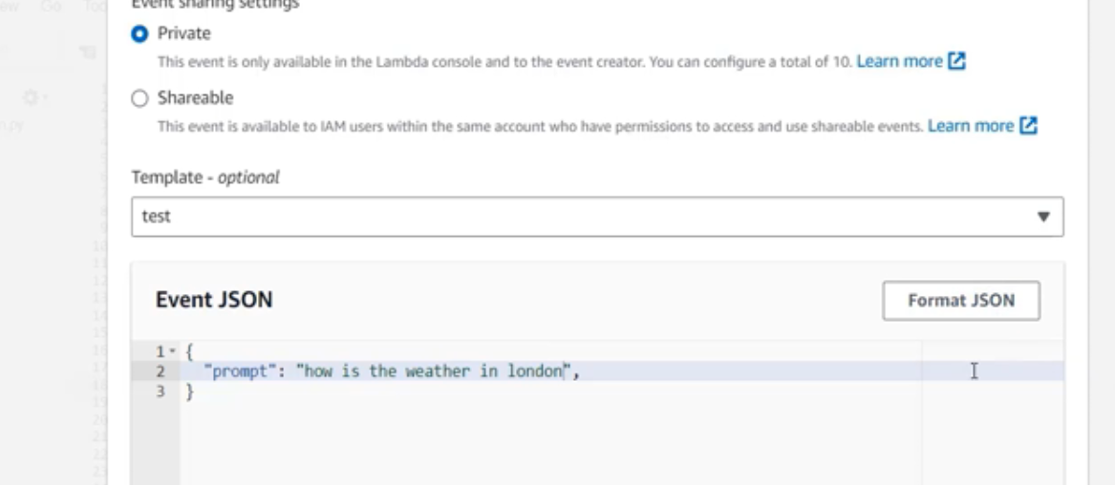

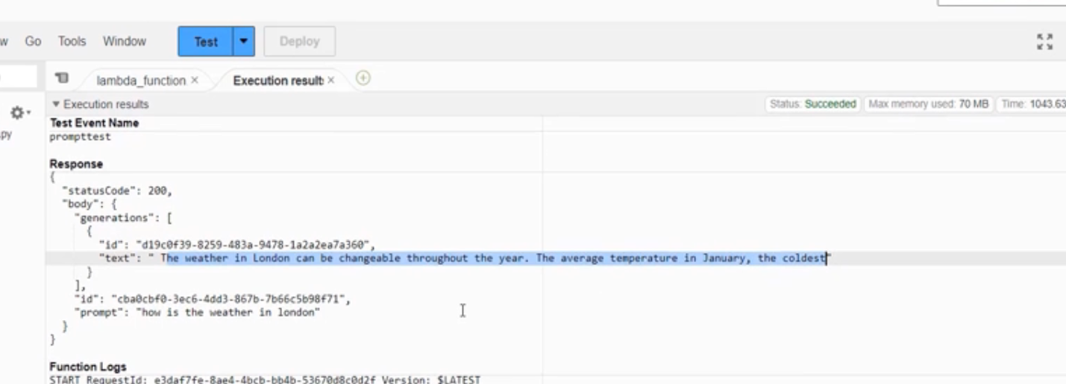

Prompt as :

{

"prompt" : "$input.params('prompt')"

}

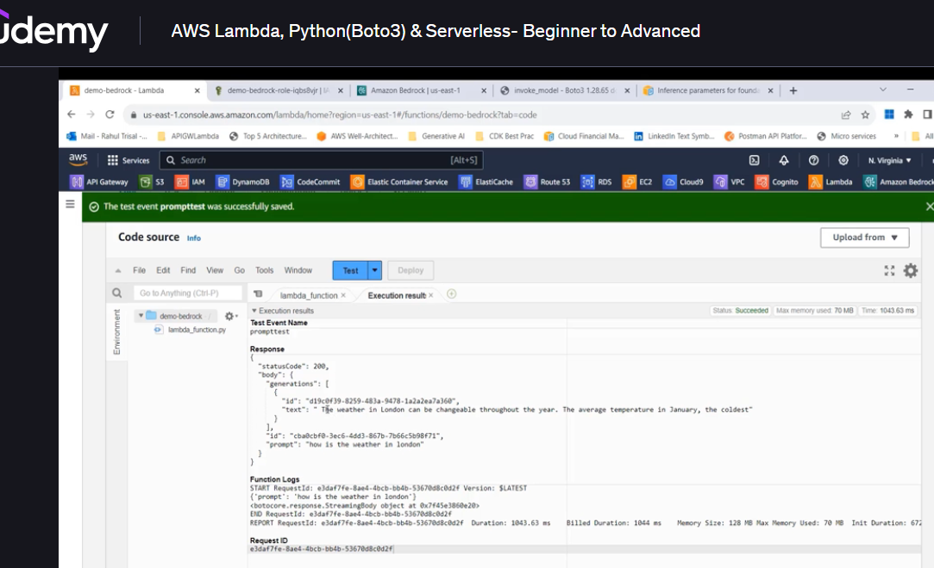

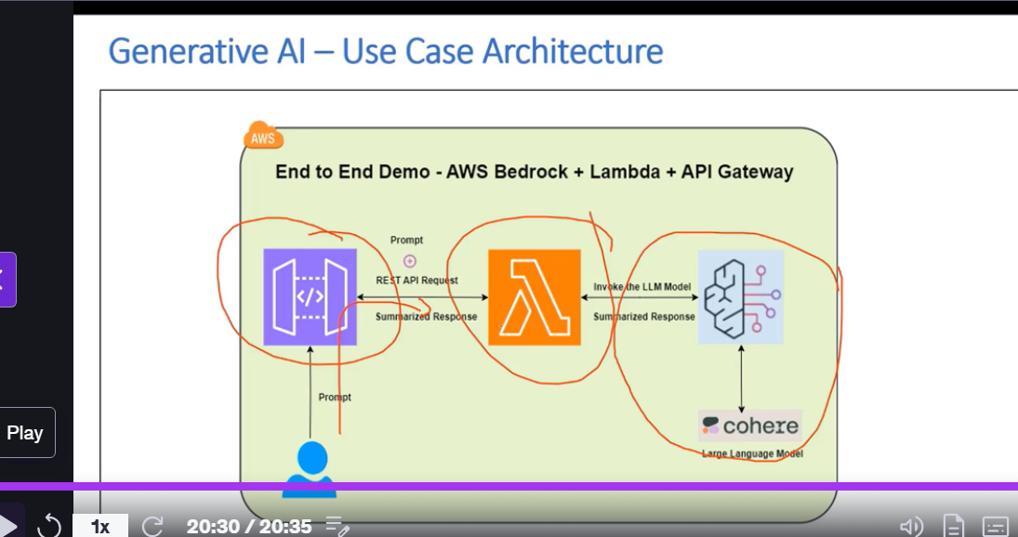

LAMBDA and COHERE have already enrolled.

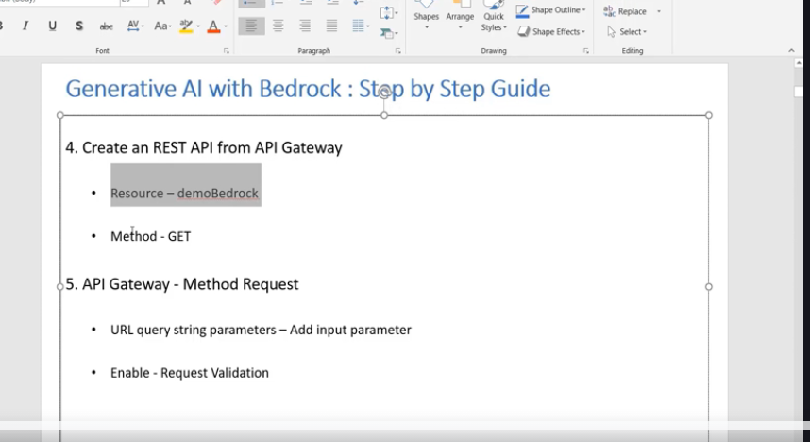

DemoBedrock

DemoTextSummarization 🡪 Resource Name

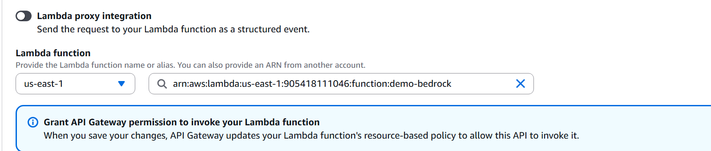

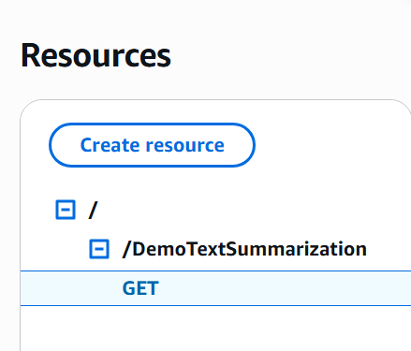

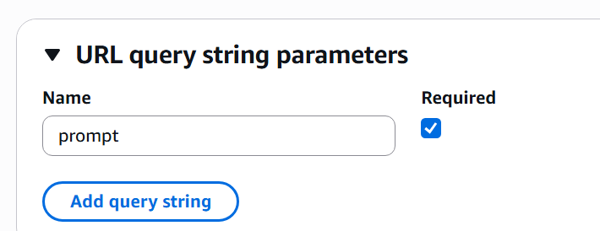

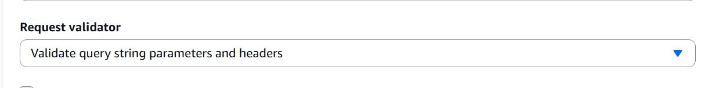

SAVE

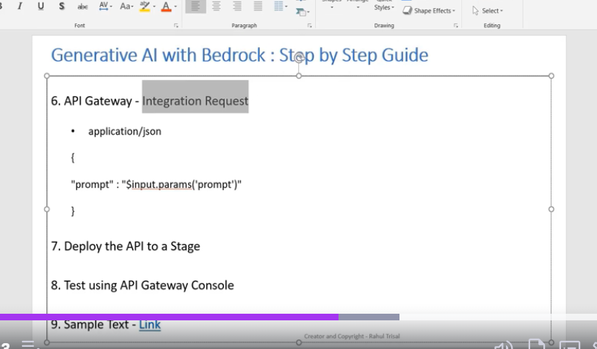

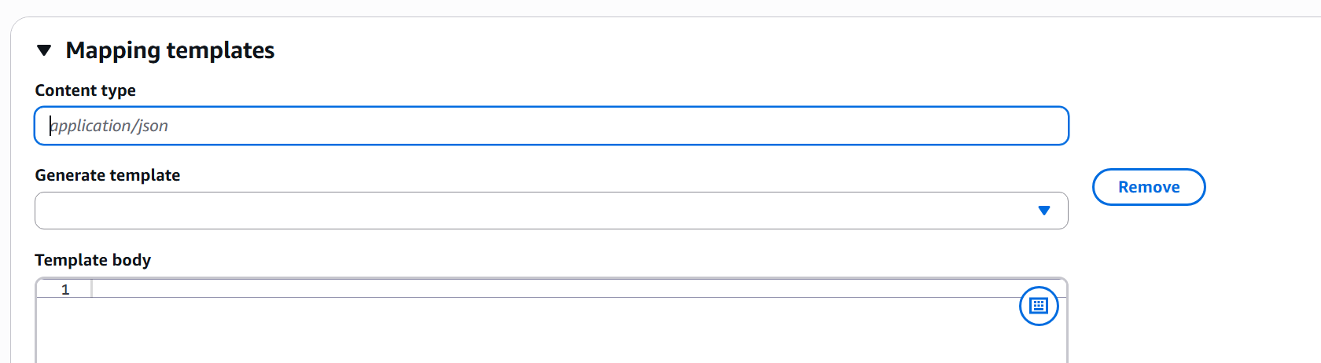

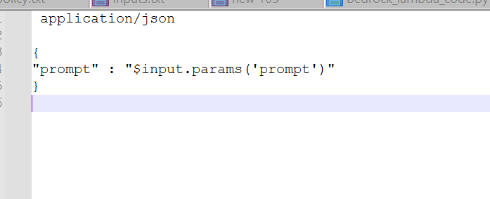

Deploy API

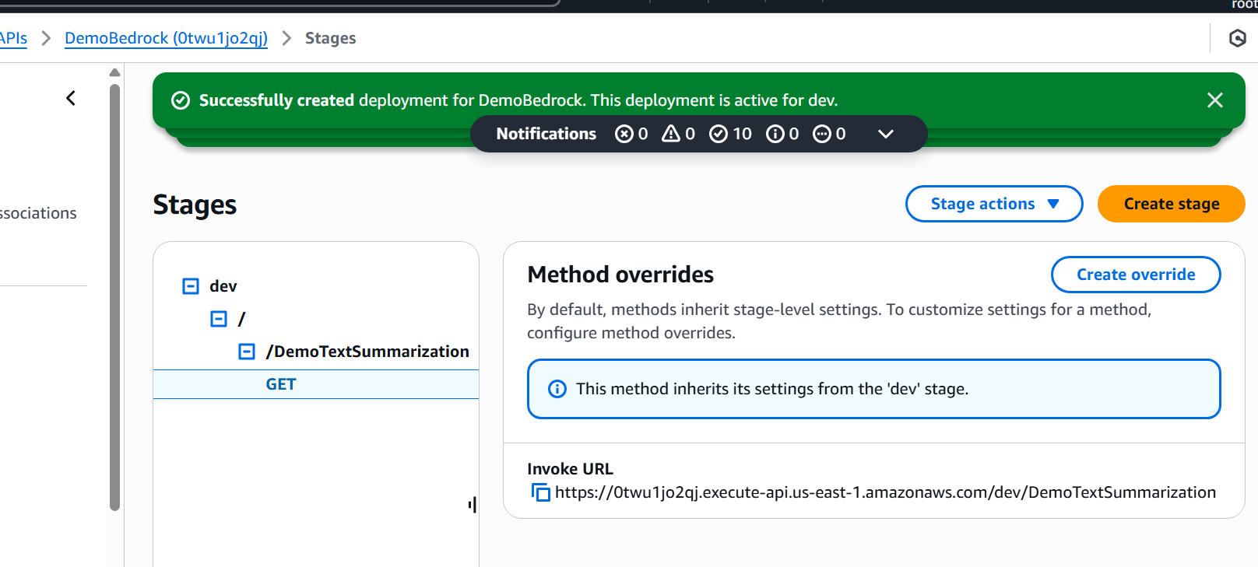

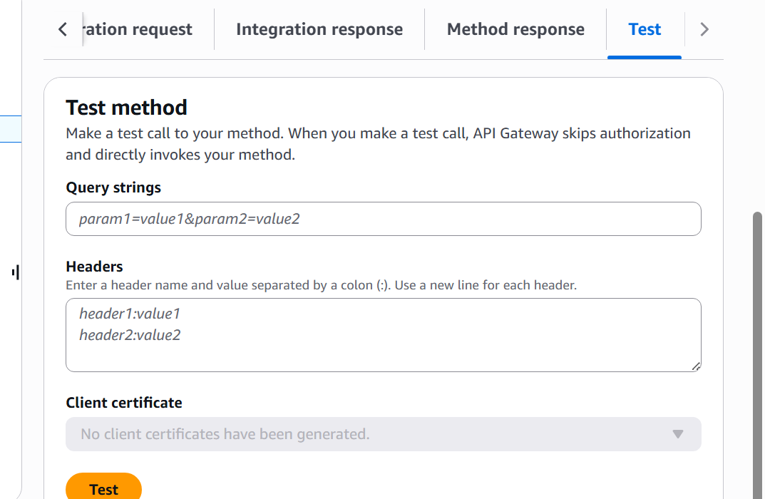

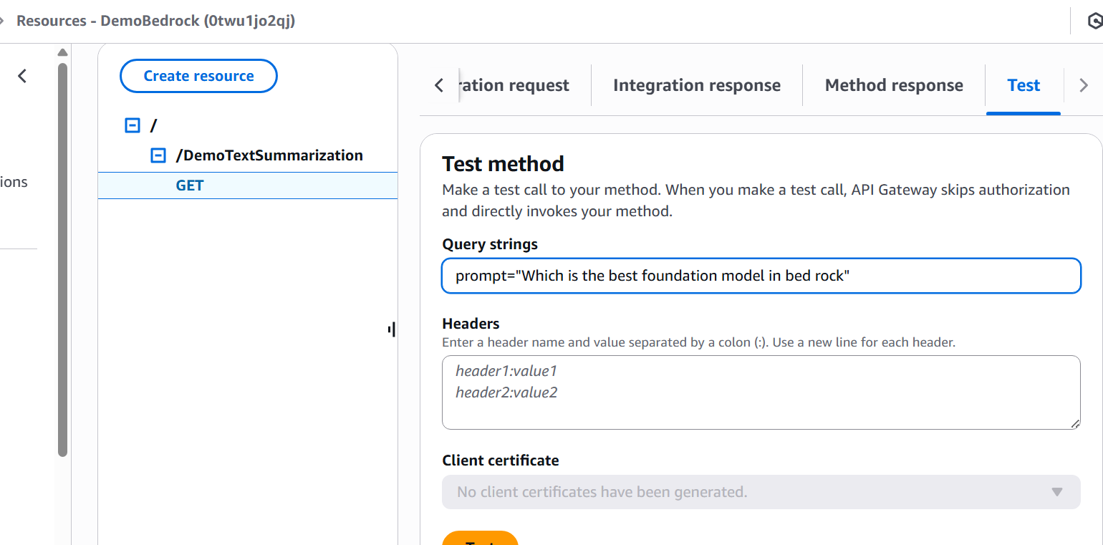

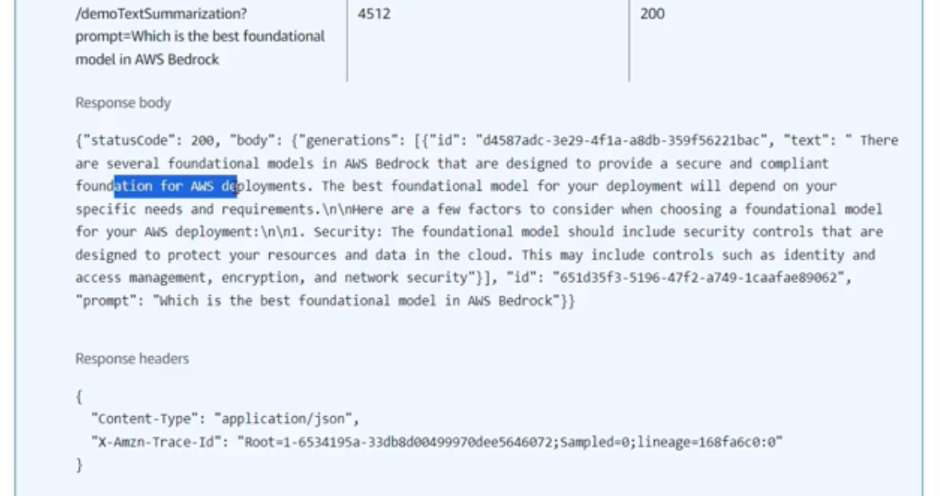

Summarize



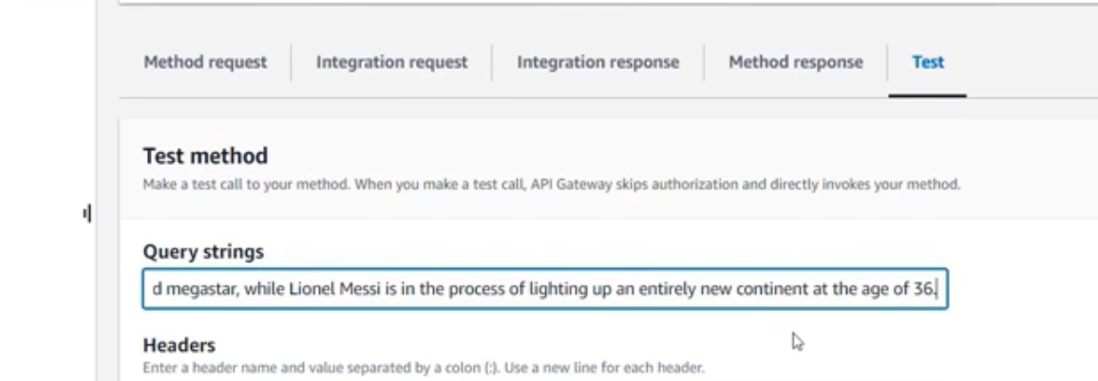

Test:

